Kth largest/smallest element in an array
Problem Statement: Given an unsorted array, print Kth Largest and Smallest Element from an unsorted array.
Examples:
Example 1:
Input: Array = [1,2,6,4,5,3] , K = 3
Output: kth largest element = 4, kth smallest element = 3
Solution 2: Using Heap
- The idea is to construct a max-heap of elements. Since the top element of the max heap is the largest element of the heap, we will remove the top K-1 elements from the heap. The top element will be Kth's Largest element.
- To get the Kth Smallest element, we will use a min-heap. After the removal of the top k-1 elements, the Kth Smallest element is top of the Priority queue.
Let the array be
[17,7,2,30,21] and k = 3
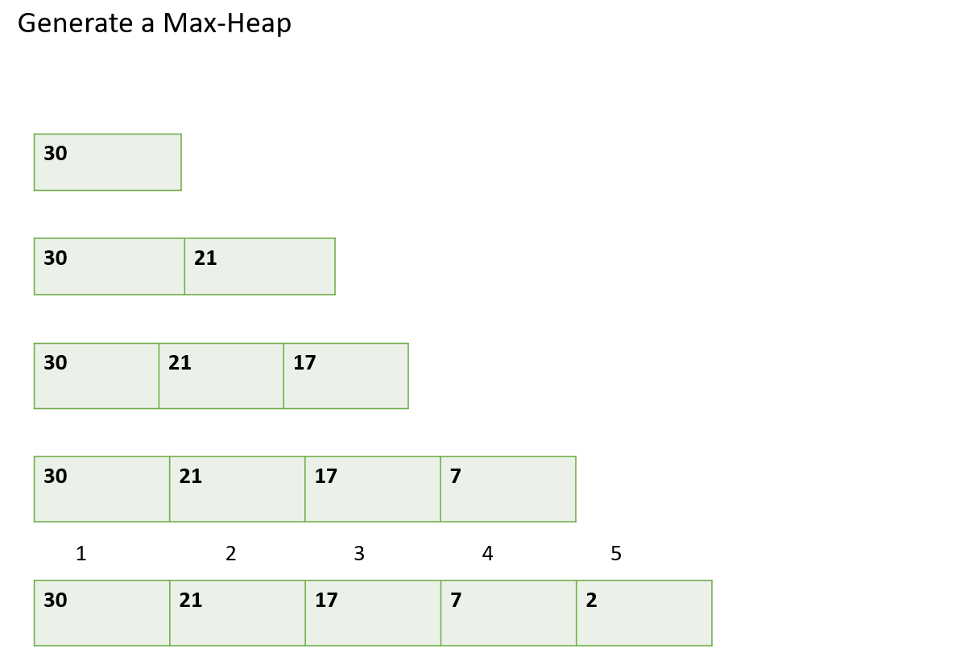
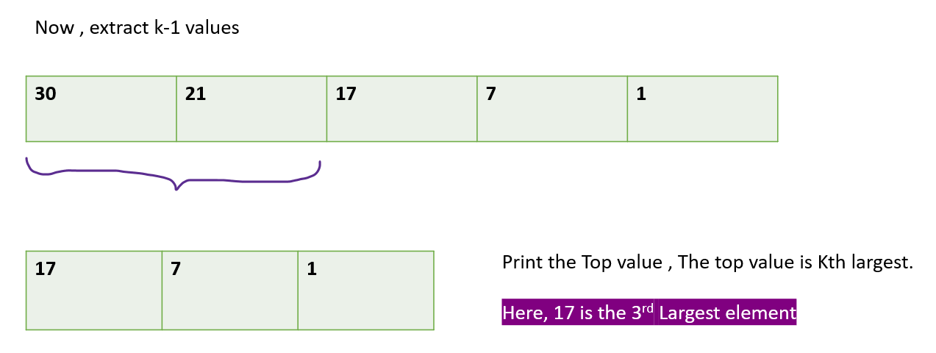
Similarly, for the smallest kth element we will be using Min-Heap. After, extracting the top k-1 values will be having Kth Smallest element.
Code:
class Solution {
static void kth_Largest_MaxHeap(int[] arr, int k) {
PriorityQueue<Integer>pq= new PriorityQueue<>((a,b)->b-a);
int n = arr.length;
for (int i = 0; i < arr.length; i++) {
pq.add(arr[i]);
}
int f = k - 1;
while (f > 0) {
pq.remove();
f--;
}
System.out.println("Kth Largest element "+pq.peek()) ;
}

static void kth_Smallest_MinHeap(int[] arr, int k) {
PriorityQueue<Integer>pq= new PriorityQueue<>();
int n = arr.length;
for (int i = 0; i < n; i++) pq.add(arr[i]);
int f = k - 1;
while (f > 0) {
pq.remove() ;
f-- ;
}
System.out.println("Kth Smallest element "+pq.peek()) ;
}
}
Time complexity: O(k+(n-k)*log(k)) , n = size of array
Space complexity: O(k)

